# Interview Tracker System SBA3

Visitors can perform the follow actions:

Allows to add a user

End point : POST <http://localhost:7777/user>

Request:

{

    "userId" : 1,

    "fname" : "january",

    "lname" : "february",

    "email" : "test@test.com",

    "mobile" : "1234567890"

}

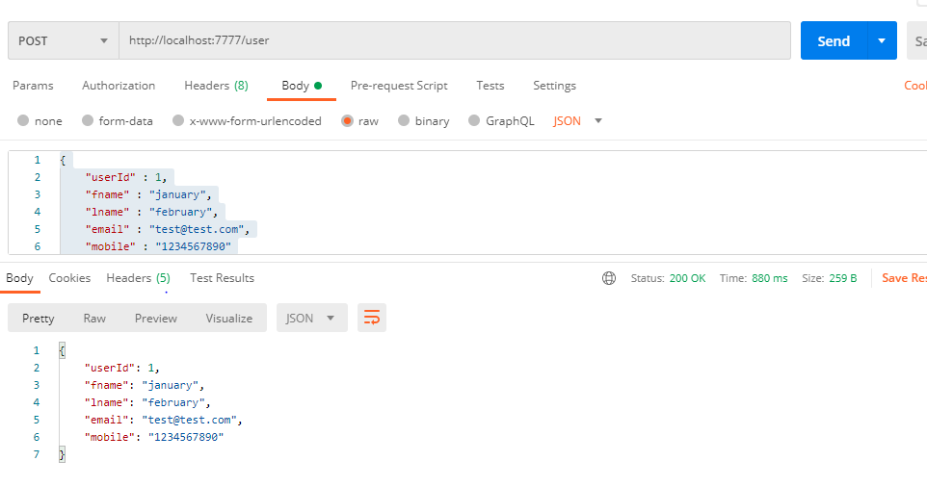

# Allows to delete an existing user

End point : Delete <http://localhost:7777/user/1>

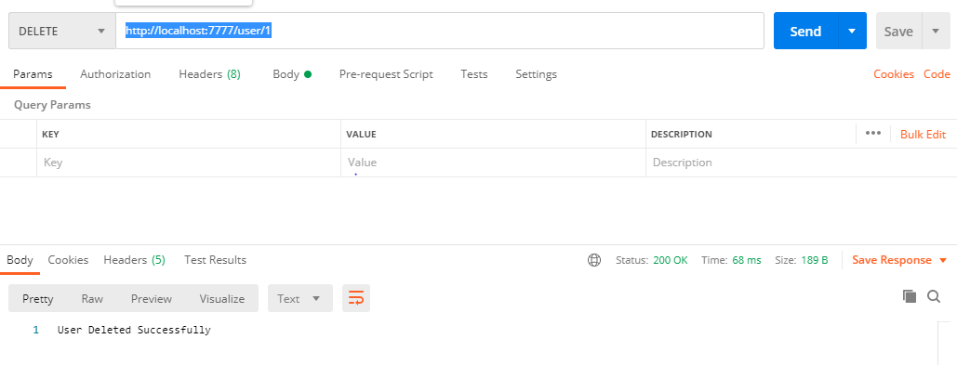

# Allows to display all users

End point : get <http://localhost:7777/user>

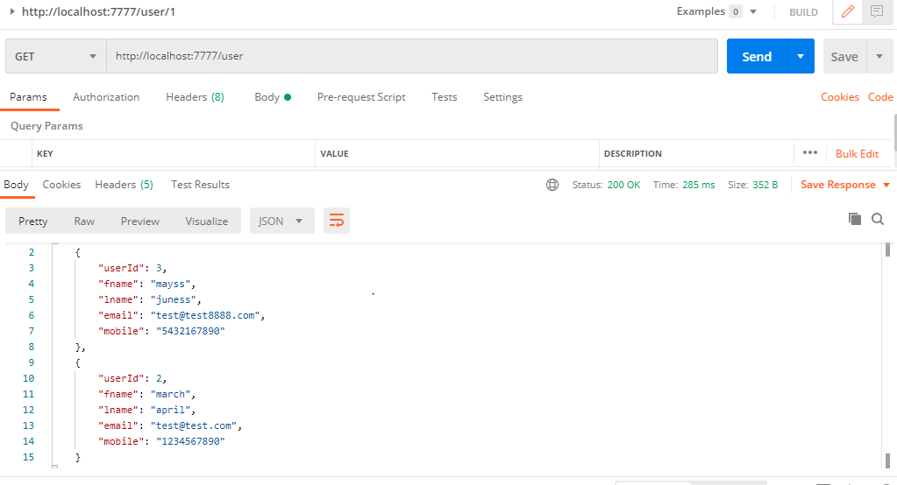

# Allows to add interview

End point : post http://localhost:7777/interview

{

    "interviewId":6,

    "interviewrName": "sneha",

    "interviewName" : "teacher",

    "userSkills":"maths science",

    "date":"2020-12-25",

    "time":"11:30",

    "interviewStatus":"in discussion",

    "remarks":"verify"

}

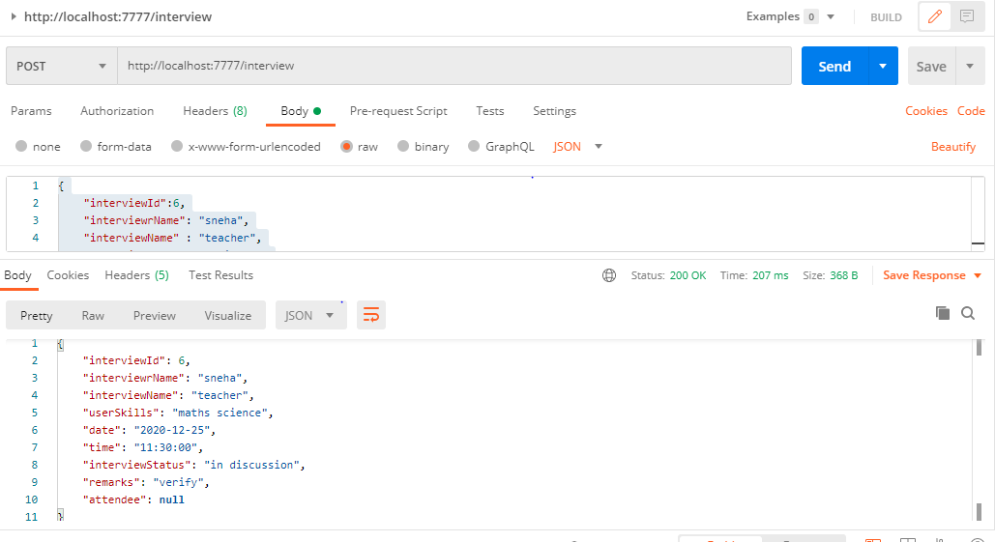

# Allows to delete an existing interview

End point : delete <http://localhost:7777/interview/6>

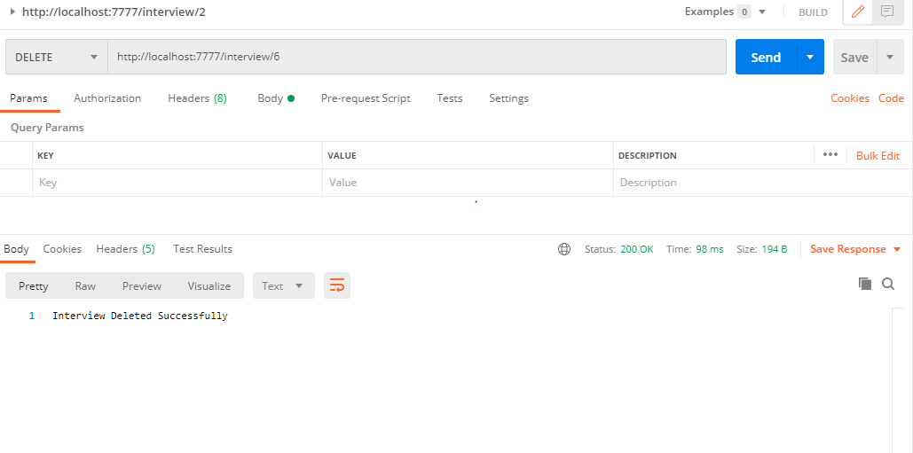

# Allows to update interview status on go

End point : put <http://localhost:7777/interview/updateStatus/1/scheduled>

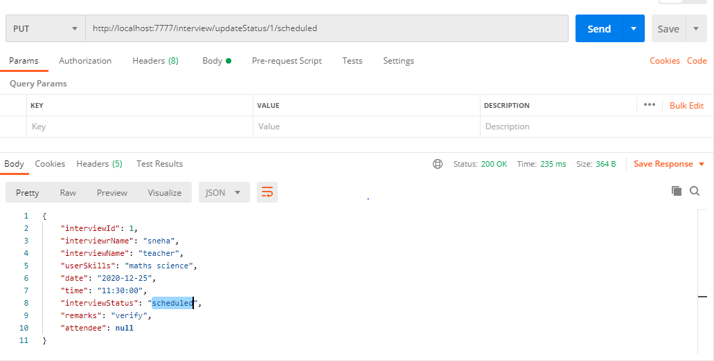

# Allows to search interview on the basis of interview anme and interviewer name

End point : get <http://localhost:7777/interview/showInterviews/artist/anjali>

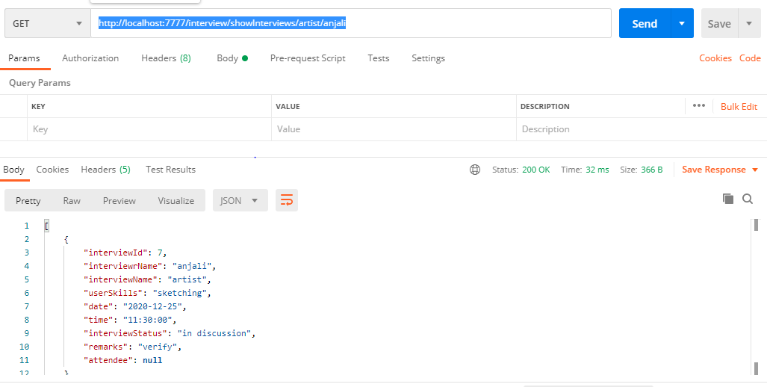

# Allows searching total no of count of interview

End point : get http://localhost:7777/interview/count

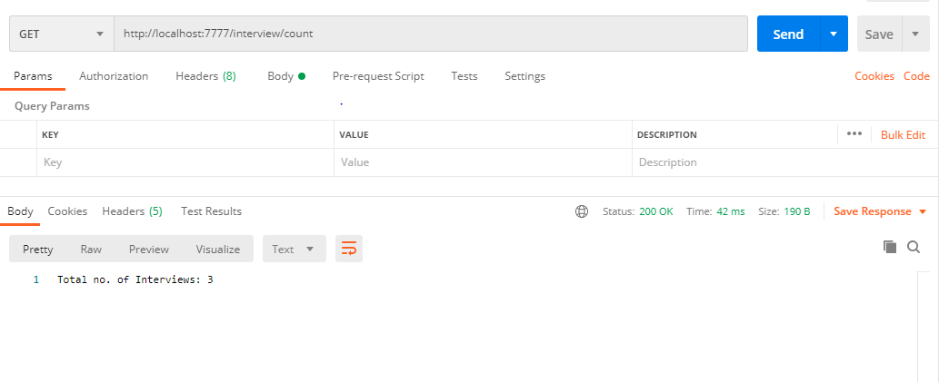

# Allows to display all interviews

End point : get <http://localhost:7777/interview/showInterviews>

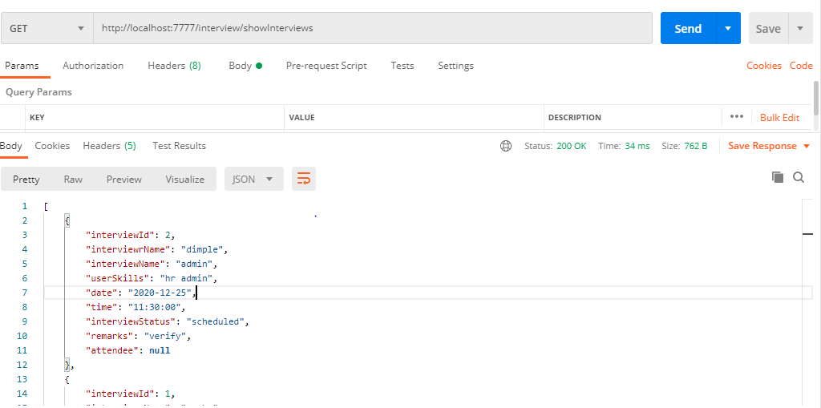

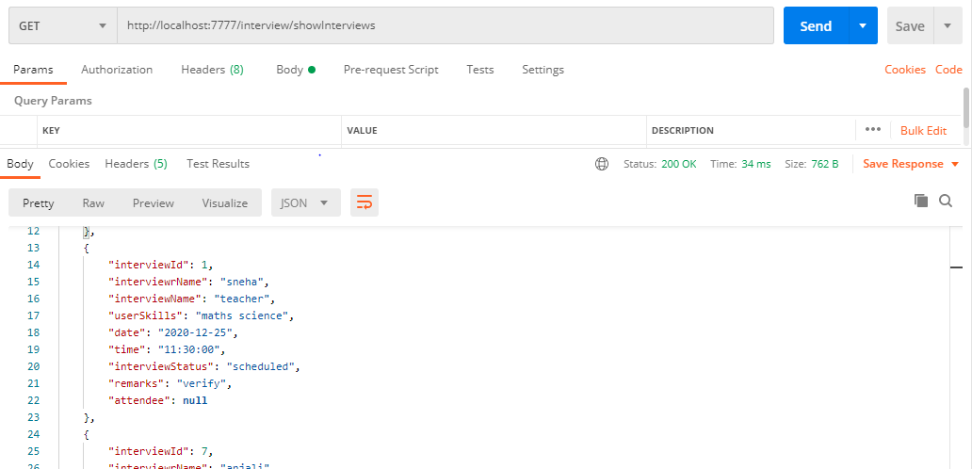

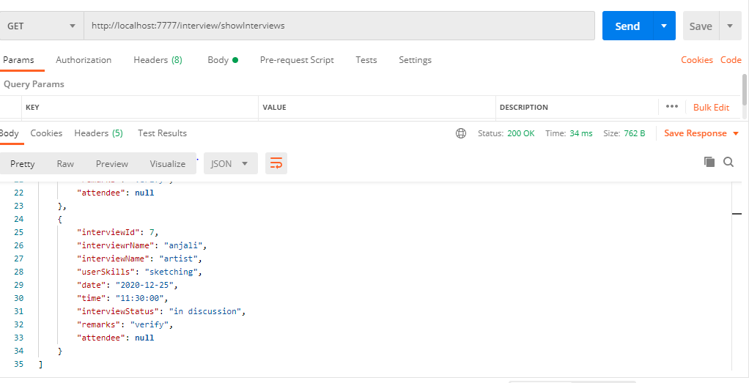

# Allow to add attendee to an interview

1. Add existing user as attendee to xiting interview :

End point : put <http://localhost:7777/interview/addAttendee>

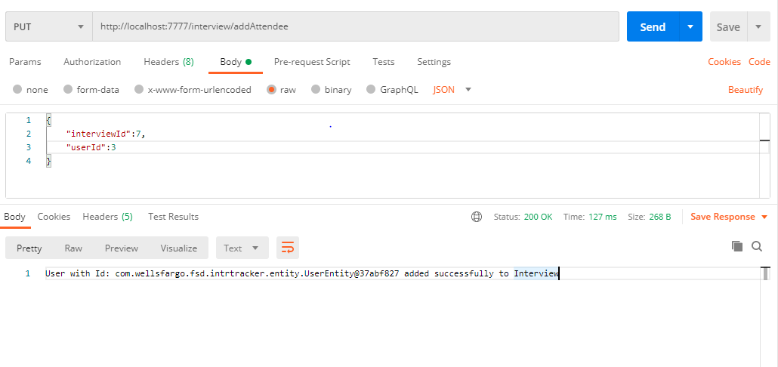

# Allow to show all attendee of an interview

End point : get <http://localhost:7777/interview/showAttendee/7>

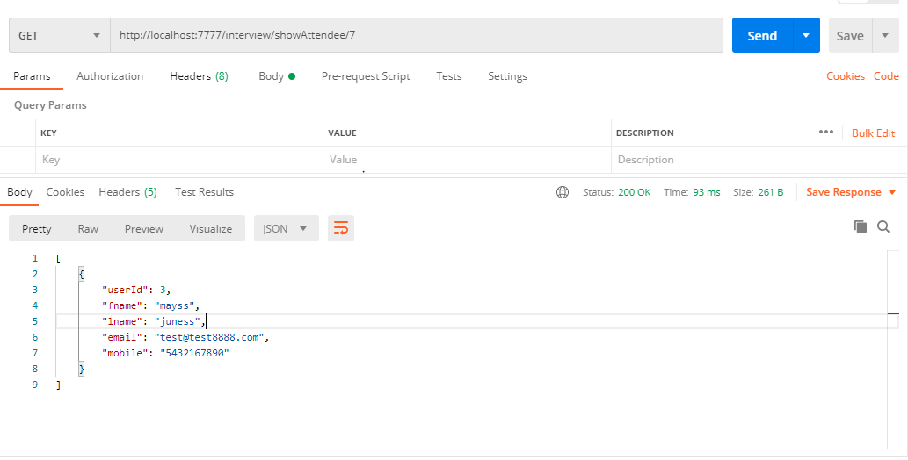

# Assumptions,dependencies,risks/constraints

While adding a user to interview as attendee, if user id already exists, it should thow a custom exception

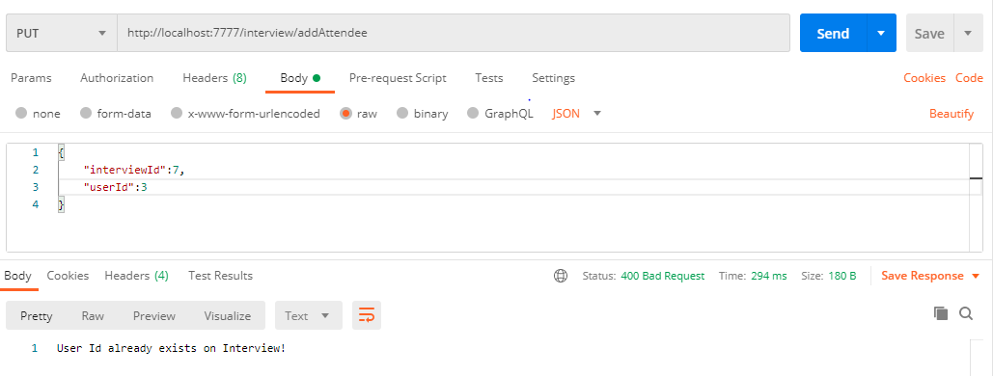

While deleting the user and interview also,assumed that is already exists else throw an custom exception

